**Session 6 (unit 4): Friend functions and this keyword and Access Specifiers**

|  |  |
| --- | --- |
| Roll No. A016 | Name: Varun Khadayate |
| Program: B-Tech (CSBS) | Division: SY |
| Batch: 1 | Date of Submission: 18-09-2020 |

1. **How a member function of a class can acts as a friend of another class.**

**Ans:** We can access function of one class as a friend of another class by same way as we make a function as a friend of a class. But, here is the catch, we have to add **class_name::** instead of **class_name:** declaration before the name of that function in the class whose friend it is being declared.

**CODE:**

#include<iostream>

#include<string>

using namespace std;

class roll_no;

class final_data

{

public:

void display(roll_no obj);

};

class roll_no

{

int x;

public:

roll_no()

{

x = 16;

}

friend void final_data::display(roll_no);

};

void final_data::display(roll_no obj)

{

cout << obj.x << endl;

}

int main()

{

roll_no rn;

final_data fd;

fd.display(rn);

return 0;

}

**OUTPUT:**

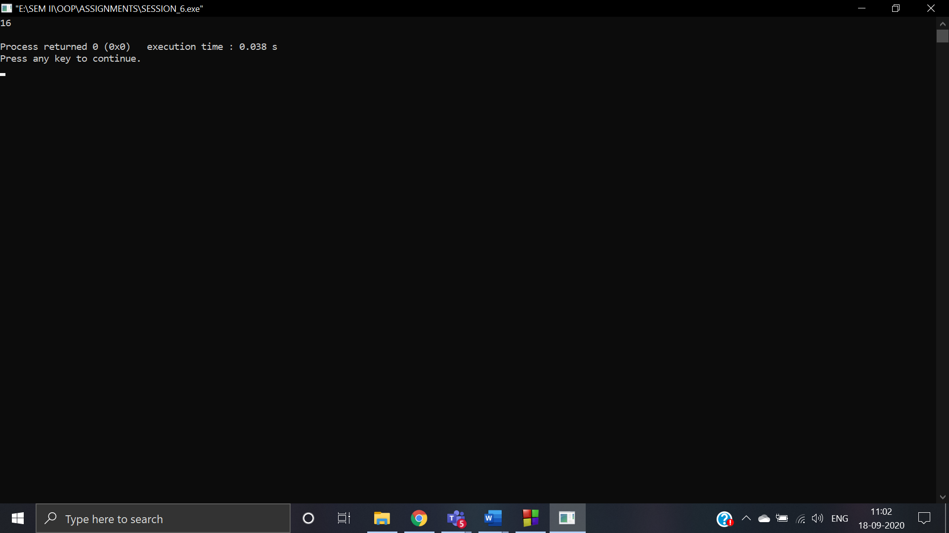

1. **State with the help of an example how ‘this’ keyword can be used in place of constructors in a class. Take an example of entering the student’s details and his marks in three subjects and displaying them using this keyword.**

**ANS:** “this” keyword is basically a pointer that points to the current instance (object) of the class. Hence, this is known as this Pointer in C++. There are following uses of this keyword in the C++:

* Access the currently executing object of a class.
* Access the data members of the currently executing object.
* Calling the member functions associated with the currently executing object.
* To resolve the shadowing issue, when a local variable has a same name as an instance variable

**CODE:**

#include<iostream>

using namespace std;

class student_report

{

public:

char name[30];

int x,y,z;

void student_data();

void marks();

void final_data();

};

void student_report :: student_data()

{

cout<<"Enter the name::";

cin>>name;

}

void student_report :: marks()

{

cout<<"\nEnter marks in subject 1:";

cin>>x;

cout<<"\nEnter marks in subject 2:";

cin>>y;

cout<<"\nEnter marks in subject 3:";

cin>>z;

}

void student_report :: final_data()

{

this ->student_data();

this ->marks();

cout<<"\n";

cout<<"\t THE STUDENT REPORT";

cout<<"\nName of student::"<<name;

cout<<"\nMarks in subject 1::"<<x;

cout<<"\nMarks in subject 2::"<<y;

cout<<"\nMarks in subject 3::"<<z;

}

int main()

{

student_report sr;

sr.final_data();

return 0;

}

**OUTPUT:**

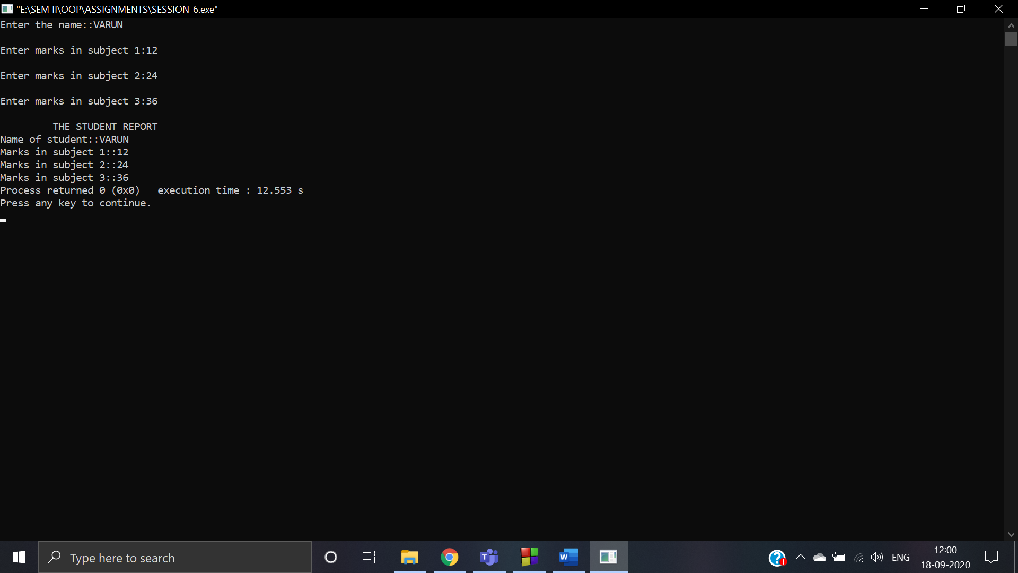

1. **WAP that can calculate the electricity bill of a person under following conditions:**

|  |  |
| --- | --- |
| **Unit consumed** | **Tariff** |
| **First 100 units** | **Rs. 5 Per unit** |
| **next 200 units** | **Rs. 7 Per unit** |
| **next 300 units** | **Rs. 12 Per unit** |

**The class must include details of the customer like his id, name and the functions read() to accept user inputs, display() to display total bill and a function cal_tariff() to calculate his total bill. Use appropriate access specifier sections and define all the functions outside the scope of the class using the scope resolution operator.**

**Ans: CODE:**

#include<iostream>

using namespace std;

class electricity_bill

{

int user_id,ut_cd,amt;

public:

char name[12];

void read()

{

cout<<"\nEnter the user id ::";

cin>>user_id;

cout<<"\nEnter the name of the user::";

cin>>name;

cout<<"\nEnter the units consumed::";

cin>>ut_cd;

}

void cal_tariff();

void display();

};

void electricity_bill :: cal_tariff()

{

if (ut_cd <= 100)

{

amt = ut_cd * 10;

}

else if (ut_cd <= 200)

{

amt = (100 * 10) +

(ut_cd - 100) * 15;

}

else if (ut_cd <= 300)

{

amt = (100 * 10) +

(100 * 15) +

(ut_cd - 200) * 20;

}

else if (ut_cd > 300)

{

amt = (100 * 10) +

(100 * 15) +

(100 * 20) +

(ut_cd - 300) * 25;

}

}

void electricity_bill :: display()

{

this -> read();

this -> cal_tariff();

cout<<"\n";

cout<<"\tThe Electricity bill data";

cout<<"\nUser id::"<<user_id;

cout<<"\nName of the user::"<<name;

cout<<"\nUnits consumed::"<<ut_cd;

cout<<"\nElectricity bill::"<<amt;

}

int main()

{

electricity_bill eb;

eb.display();

return 0;

}

**OUTPUT:**

